Welcome to GDI!

It is my goal in writing this short e-book to help you make a full-time passive income more quickly and easily than you likely believe is possible.

I'm confident that I'll be successful in this endeavor.

My name is Lee, but that's really not important. In fact, you may have received this e-book as a gift from somebody else, who has never met me and who has no idea who I am.

It's perfectly okay if we keep it that way. :)

Again, who I am isn't important. Just know that I have earned life-changing income on the internet, and I intend to earn a whole lot more... while helping you to do the same at the highest level possible.

This book will guide you on how to create an “Income For Life”.

What is GDI?

GDI is a domain registrar, hosting platform, business email address solution, and website builder. It's four important things... all under one roof. Watch this video.

Moreover, GDI is an opportunity.

In fact, it may just be the single greatest opportunity I've seen in my 11+ years doing this stuff! ;)

And that's because it has a massive five-tier (yes, FIVE-TIER) affiliate program built right into it. This means that, you promote GDI and make a passive, recurring, monthly commission on everyone who becomes a customer through your link... for as long as they remain a customer.

And since GDI's affiliate program is every bit as much a part of their success as their product is, the customers you refer will also earn commissions when they refer people.

But here's where it gets really interesting...

SO WILL YOU!

Yes, you earn another passive, monthly income on all new customers generated by your referrals!

ALL OF THEM!

So if you personally refer 20 people, you wind up earning monthly revenue on all new customers that THEY sign up, in addition to continuing to earn a monthly payout on your 20 referrals/customers themselves.

Make sense?

But remember when I said that it's a FIVE-tier affiliate program?

This means that, whenever your referrals' referrals bring in new customers, you earn commissions on them as well! And when THOSE people bring in new customers, you're paid for them too. And them... and them!

Mind blown yet?

There are literally GDI affiliates bringing in $20,000 per month. A few are even earning over 30k! And their income continues to grow as their “downline” continues to grow.

And don't for a second think that this is some flash in the pan that's going to fizzle out in the near future. These guys have been going strong since 1999, and have a stellar reputation.

This is very much legitimate, and can result in wealth for you.

By the way, this is a very special e-book you're reading.

Why?

Because this very e-book can serve as your most prized marketing tool.

That's because I'm allowing anyone who gets their hands on it to give it away themselves to gain new email leads and GDI signups!

That's right, the very marketing tool that I've created for myself to use in an effort to enhance my own GDI profits is the very same marketing tool that you can use to greatly enhance yours!

And it gets even better, because you can also pass these giveaway rights along to your own subscribers. This means that everyone to whom you give this powerful e-book can also give it away to others!

Remember, with a 5-tier affiliate program, you'll benefit when your referrals make sales, and when their referrals make sales, and so on... so you may as well let your new subscribers give this puppy away, too. :)

I hope I'm making sense.

In just a moment, I'll give you your action plan.

It's just very important that you understand this. As such, let me just very quickly give you a rough visual representation.
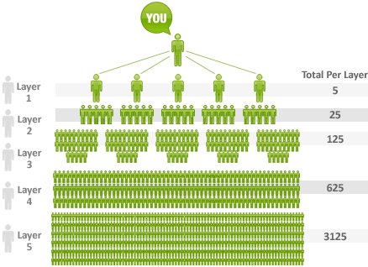

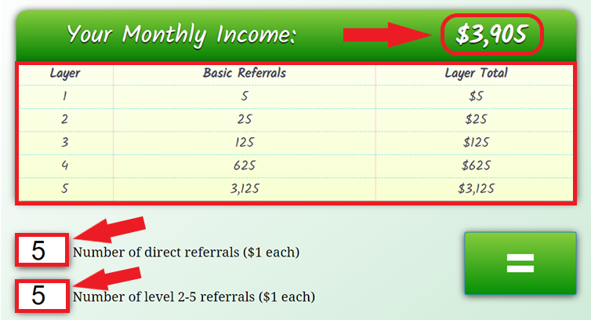

So if you and everyone else below you refer just 5 people each till their 5th level, you would all be earning $3905 every month recurring. Once the above team structure is set up for you, even if you stop promoting, you would still continue to get $3905 till you team remains like above and continues to pay their recurring payment of $10 per month. And why would they not….as long as they too continue to earn amounts as shown above.

And here's a bit of fantasy, but it's always fun to dream...
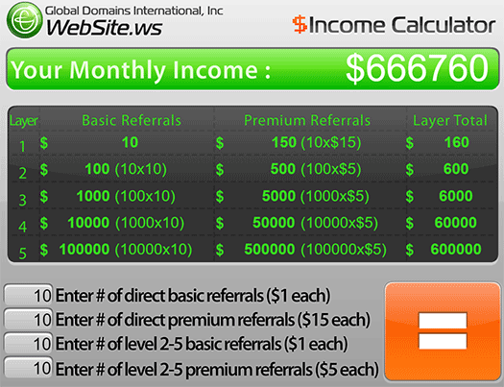

Now obviously, the math would never work out like this in a million years. So please don't give yourself any false hope that this system will earn you over half a million dollars per month.

Many (if not most) of the people you bring in as customers won't promote GDI aggressively, if at all. Some folks just want to use the domain & hosting & site-building stuff... and that's fine! Nice to know that there's an actual product of value backing all of this madness.

(That's undoubtedly why they've been going strong since 1999!)

But here's the thing...

All that you need to focus on is your own marketing.

Let your “downline” work itself out.

Now sure, you can provide them with quality training and tools (which is why I'm giving you this e-book and lead capture system. Details coming soon)...

But ultimately, your job is to attract as many new customers as you possibly can. Because even if only 5% of the people you bring in are highly ambitious and they move mountains to promote GDI and take this thing to the top...

That's still 5 out of every 100. So bring 1000 people in... or 10,000!

Seriously, you don't need everyone to be good. You just need a small few to be great. So you just focus on bringing people in. Let the numbers work themselves out. I trust you'll be pleasantly surprised.

“In the Graphic Above, It Mentions 'Premium Referrals.' What's That?”

Good eye!

This is GDI's upgraded membership.

Premium GDI accounts come with additional perks, both for customers and for affiliates. The upgrade isn't necessary, but the benefits are undeniable.

As such, I highly recommend that you upgrade your account as soon as you're able to. It's very well worth it, as it requires no extra effort from you, yet pays you up to 14 times the commissions as the basic account!

Let me share another graphic with you...

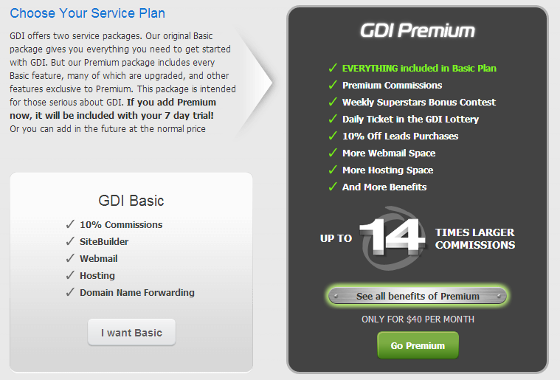
For our purposes here, the two most important upgrades to take note of are the first two (Premium Commissions and Weekly Superstars Bonus).

The Weekly Superstars Bonus:

I don't often use the word “amazing” because it's overused and cheesy. But in this case, it applies. And that's simply because of its insane level of generosity. Mind-blowing, actually.

Quite simply, you earn a $100 bonus for every 5 new customers you refer in a week. Remember, they only have to spend $10 per month. So this bonus really represents up to a 2000% one-time commission...

(5 customers x $10/mo. = $50/mo. revenue, of which you earn $5/mo...
The $100 bonus is 2000% of that.)

And that's in addition to your $1/mo. regular recurring commission!

Pretty insane. And there's no limit. You bring in 10 new customers per week, and you earn a $200 bonus. 100 new customers and that's a cool $2000 each and every week you pull this off.

Now, I admit that 100 new customers per week is mighty ambitious. But does that mean it's impossible? Of course not! There are 7 billion people on this globe of ours. 100 is microscopic in the grand scheme of things.

I'm sure that part of the (but not the only) reason why GDI is willing to pay you $100 for every 5 new customers you refer is that they know a good percentage (in my experience about 30%) of people will upgrade their accounts to Premium. This creates harder workers and more revenue.

By the way, let's talk about those...

Premium Commissions:

This is an even bigger deal than the bonus.

While earning a $100 bonus for every 5 new customers you refer in a given week gives you a nice boost of spending cash, the Premium commissions can change your life on an ongoing basis.

And that's because these commissions, just like your basic commissions, extend five tiers down. Here's how it works...

- As a Premium member, you earn $15 per month on every Premium account you refer (you needn't do anything extra, as both the system AND this e-book do most, if not all of the selling for you... you just keep referring new customers by simply giving this e-book away for free).

- Every time anyone in your “downline” makes a Premium referral (also by simply giving this e-book away), you earn $5 per month.

- This is in addition to the 5-tier, $1/mo. Basic commissions you earn on folks who decide not to upgrade their accounts.

If you don't upgrade your account, but your customers (aka downline) decide to upgrade theirs, you don't earn any extra income. You must yourself be a Premium member in order to earn those higher commissions.

Your Basic account is $10 per month, and it's absolutely fine to remain basic until your income enables you to justifiably upgrade your own account.

Your Premium account will cost you $50 per month. So it's a significant boost in investment, but also a significant boost in income.

I'm personally a Premium member, and can tell you that the difference between the two membership levels is truly night and day. Very well worth it, if you really want to hit the ground running.

But again, if $50 per month is a lot for you right now, then start slow. Grab that $10 Basic account, give this e-book away as per my instructions below, and upgrade your account using some of your profits! No shame in that.

Get Started Here>>

No matter which level you're able to start with right now, the important thing is that you get started right now. Every day, including today, is a valuable opportunity to bring in new customers and create a passive income that can potentially change your life in a massive way.

Click the “Get Started Here” link above and do just that. Start your FREE trial right now and start giving away this e-book ASAP!

In fact, let's talk about how to do just that...

How to Earn GDI Commissions by Giving Away This FREE e-Book:

Okay, so at this point you should have a FREE trial GDI account, regardless of whether it's soon to be a Basic account or a Premium account. If you don't yet have this account, there's really no reason to continue reading.

Everything that follows is predicated upon you having an account.

Again, start your free trial by clicking this link and following the simple sign-up instructions given to you. It's easy!

Once you're inside your GDI account, the first thing you'll want to do is educate yourself about your membership. Check out the site building functionality, special promotional tools, and all things GDI.

As this can represent a massive, passive, ever-growing income for you, you really do owe it to yourself to watch all of the video tutorials, click all of the links, and read as much as possible. Soak it all in! Take your time.

The reason you want to do this is to enable yourself to make full use of the many promotional tools and strategies that the GDI team has put in place for you. They want you to succeed. They want to help you.

It's your job to let them!

Even if you're giving this e-book away, which you absolutely should be, it's still only going to benefit you to learn all about this new income source of yours. :)

Okay, so let's start getting this e-book out there...

Step One - Download Your E-Book

Your first step is to Download the E-Book where you can make the changes.

Step Two – Edit Your e-Book:

You'll want to replace my GDI links throughout this e-book with your own.
Go to your GDI Backoffice and then go to “My replicated websites” under “Affiliates”. Choose any of the websites that you like and use their link. I have used “GDI Video 1 Autoplay”. Make sure that you use the ones in English if you are sending to people who understand only English. Once your Ebook is ready you can start sharing it with people you know or share with interested people on social Media.

Step Three–Automation

Automation can help you take your GDI business (and any other business you have) to greater heights and build a list of clients for you who can regularly connect with and reach out with new offers later on.

There is another tool which you can use for this called “The Conversion Pros”(TCP). TCP will give you all the tools you need including a landing page creator and an autoresponder to send automated emails to your prospects.

It is FREE to start for 14 days (No credit card required) and then just $50 per month.

While my sincere advice to you would be to also continue with this as a paying member after 14 days as it can generate another source of income for you, it is fine even if you join it just for 14 days, use it to generate your prospects for GDI and then discontinue after 14 days if you do not have the $50 for TCP.

If you join TCP as a paying member, you can also promote TCP and you will get $25 for every person who joins you as a paid member. So just by referring two people, TCP can be free for you.

JOIN TCP HERE and learn to set up your pages and autoresponder as explained in the videos.

Step Four – Upgrade Your GDI Account to PREMIUM:

This step is optional, but as you're about to start driving traffic, I want to make sure that you're giving yourself every advantage to earn as much as possible.

Step Five – Send Traffic to Your Squeeze Page:

There are many ways to drive traffic. Go to MyOnlineStart.com to learn the best traffic sources... 100% for free!

Inside The Conversion Pros Also There is a ton of training on how to drive traffic using social media and Craigslist. Focus on just one method at a time.

And that's really all there is to it!

Again, all you need to do is:

- Get your GDI free trial here.
- Go to this page to download your Ebook
- Edit this e-book and share it on social media
- Automate GDI with TCP (Optional but recommended)
- Upgrade your GDI account to Premium (optional).
- Go to MyOnlineStartup.com and go through the free course.
- Once you've picked a traffic method or two, drive traffic daily.

Following these 6 simple steps can change your life forever, and I'm very much convinced that they will, especially if you're consistent.

To spell this out for you just a little more clearly, here's what you're actually accomplishing by following the six steps above...

- You're replacing my GDI links in this e-book with your own.

- You're cloning my funnel on The Conversion Pros.

- You're giving away this e-book via your new funnel.

- You're driving traffic to this funnel using your favorite traffic methods from MyOnlineStartup.com.

- As people grab your newly-branded version of this e-book, they'll be signing up for GDI using your link! This will give you a passive, recurring monthly income.

- These folks will be following the same instructions that you're following as they go through this e-book. They'll re-brand the book with their links, and give it away via my instructions. When their leads become GDI customers, you'll earn tier-2 commissions!

- When those 2nd tier customers give this e-book away and get new signups, you'll earn tier-3 commissions!

- When those 3rd tier customers give this e-book away and get new signups, you'll earn tier-4 commissions!

- When those 4th tier customers give this e-book away and get new signups, you'll earn tier-5 commissions!

All of this, and yet all that you ever have to focus on is giving this simple, silly little e-book away to as many people as possible. Again, MyOnlineStart.com will show you the best ways of doing this. So pay close attention!

The rest will take care of itself. :)

Do you see how viral this can become for you? The harder you work, the more money you'll make. And the harder the folks to whom you've given this e-book work, the more money you'll make (and the less hard work you'll have to do)!

It really is that simple, my friend.

Just follow the steps in this e-book, and you will be well on your way to a whole new life. Remember to go to MyOnlineStartup.com to learn the best traffic strategies online. Use these strategies to send as many people as you can to your squeeze page .

You're honestly not going to find another opportunity like this out there. Trust me, I've been at this since 2008. You simply cannot beat a 5-tier affiliate program like this one.

And when you combine this viral affiliate program, this viral e-book, and the high-octane traffic methods you're about to learn at MyOnlineStart.com, that's a triple-dose of awesome that you'd be beyond foolish to ignore.

So let's do this now...

LAST CHANCE TO TAKE ACTION!

Again, all you need to do is:

- Get your GDI free trial here.
- Download your Ebook
- Edit this e-book and share on social media, emails etc.
- Automate GDI with TCP (Optional but recommended)
- Upgrade your GDI account to Premium (optional).
- Go to MyOnlineStart.com and go through the free course.
- Once you've picked a traffic method or two, drive traffic daily.

I really, really want to see you do this, my friend.

The sad reality is that most people won't. Most people won't even read this tiny 15-page e-book to the end. The fact that you have truly sets you apart. So I congratulate the heck out of you for that! :)

You've got momentum on your side.

Now you just need to take the next critical step. Complete the six actions above and finally set yourself free. You owe this to yourself. You owe it to your family. Heck, you owe it to the world to have financial abundance and be the extraordinary, stress-free badass you were always meant to be.

In my opinion, this is your ticket. The six steps above are your best chance to finally succeed in a major, major way!

Please don't squander this opportunity. That's all I ask. :)

I'm wishing you the very best. If you need anything, please contact your sponsor, whose username is Vandana and email address is vandana.nanda25@gmail.com.
Read more about GDI HERE

Thanks for reading, and for taking massive action!

